Developing and Optimizing Data Structures for an E-Commerce Order Platform in Python

Mahesh Gaire
Basanta Ghorashainee
Sai Prasanth Chowdary Moparthi
Mayurkumar Bhavikkumar Patel
Xhon Pelushi
University of the Cumberlands
MSCS-532-M20: Algorithms and Data Structures
Course Project — Final Report
Dr. Michael Solomon
July 17, 2026

Abstract
This project designs, implements, tests, and optimizes the data-structure core of an e-commerce order platform in pure Python. Six structures built from scratch serve the six workloads of a shopping session: a separate-chaining hash table is the catalog of record, a trie answers autocomplete prefixes, a binary search tree serves price-band filters, a weighted adjacency-list graph ranks co-purchased products, a binary max-heap produces best-seller, low-stock, and most-returned dashboards, and a circular-buffer queue carries orders through fulfilment. A facade class integrates them under one rule: product records live only in the catalog, and every other structure resolves SKU keys through it in constant time. A dependency-free browser portal renders the running system live, one color-coded panel per structure. Forty-two unit tests establish correctness, and a benchmark suite scales the system to one hundred thousand products and twenty thousand orders. Measured against naive baselines, dynamic resizing keeps catalog lookups flat near two microseconds where a fixed table degrades five-fold; the trie answers prefix queries 45 times faster than a linear scan; the pruned tree serves range queries 5.7 times faster than scanning; and the pure-Python heap, despite its superior asymptotics, only ties Python's C-implemented sort — a measured lesson in constant factors. Stress tests confirm the tree's predicted collapse under monotone insertion and the pipeline's atomic rejection of orders once stock exhausts. The integrated system sustains roughly 44 thousand orders per second within 65 megabytes.

Introduction
Every page of an online store is a data-structure benchmark in disguise. When a shopper types three characters into a search box, filters the results to a price band, reads a "customers also bought" panel, and checks out, the platform behind the page has answered a prefix query, an ordered range query, a graph-neighborhood ranking, and several exact-key lookups, and has then mutated stock levels and enqueued fulfilment work — all within a latency budget set by the shopper's patience. This project, set in the e-commerce domain in which members of our group work professionally, asks the central question of this course at practical scale: which data structure earns its place for each of those workloads, and what does it cost when the wrong one is chosen?
The project unfolded in three phases, integrated in this report. Phase 1 designed six structures around the customer journey and justified each choice asymptotically. Phase 2 implemented all six from scratch in pure Python — no dict-backed shortcuts for the mechanics under study — wired them into one facade, and proved them correct with forty-two unit tests and a scripted end-to-end demonstration. Phase 3 scaled the system to one hundred thousand products, measured every structure against a naive baseline, and stress-tested the designs at their documented weak points. The complete source code, test suite, benchmark data, and all figures in this report are available at https://github.com/xhon-pelushi/residency.
Literature Review
The theoretical foundations of the six structures are classical. Cormen et al. (2022) give the expected O(1) behavior of chained hashing under simple uniform hashing, the O(h + k) bound for range reporting from a binary search tree, and the O(n) bottom-up heap construction this project relies on for its dashboards. Knuth (1998) remains the definitive treatment of the sorting-versus-selection trade-off that motivates answering top-k queries from a heap rather than a full sort, and of the collision phenomena that make hash-table load factors decisive in practice. The trie originates with Fredkin (1960), whose observation — that retrieval cost should depend on the length of the key, not the size of the collection — is precisely the property autocomplete requires. Bayer and McCreight (1972) established the ordered-index tradition from which the price tree descends, and their motivating concern, keeping ordered data efficient as it grows, is this project's Phase 3 in miniature. On the hashing frontier, Pagh and Rodler (2004) showed with cuckoo hashing that worst-case constant lookups are achievable at the cost of occasional expensive rebuilds, a trade this project evaluates and declines for a read-heavy catalog.
The recommendation subsystem draws on the item-to-item collaborative filtering literature. Sarwar et al. (2001) demonstrated that computing similarities between items rather than between users scales with the (smaller and more stable) item population and produces recommendations of comparable quality. Linden et al. (2003) reported the same architecture serving Amazon.com in production, noting that item-to-item tables can be consulted in real time at web scale. Modern surveys such as Zhang et al. (2019) document the field's movement toward learned models, while confirming that co-occurrence structures of the kind built here remain the workhorse baseline against which learned recommenders are judged. This project's weighted co-purchase graph is a faithful small-scale instance of that baseline: it is populated incrementally by the order stream itself and served directly from an adjacency list.
Application Context and Requirements
The platform models a mid-sized storefront: on the order of one hundred thousand SKUs, autocomplete on every keystroke, price filtering on every results page, recommendations on every product page, and a continuous order stream whose fulfilment must update stock, sales counts, and recommendation signals. Six workloads with six distinct access patterns follow, summarized in Table 1 with the structure chosen for each. No single container serves all six: a hash table cannot report an ordered range, a sorted structure pays logarithmic or worse insertion for its order, and a graph is the only natural home for pairwise co-purchase signal. The design problem is composition, and the composition rule adopted throughout is a single source of truth: the catalog hash table owns every product record, and the five other structures store only SKU keys, resolved through the catalog in O(1) at query time. Data is never duplicated across indexes and can never disagree between them.
Customer-journey step | Access pattern | Structure | Core cost
Product page, cart, stock check | exact-key lookup | hash table (chaining, FNV-1a, resizing) | O(1) expected
Search-as-you-type | prefix match | trie, one node per character | O(L + matches)
Price filter | ordered range query | binary search tree, SKU sets per price | O(h + k)
"Customers also bought" | weighted neighborhood | adjacency-list co-purchase graph | O(d log d)
Best sellers / low stock | top-k selection | binary max-heap | O(n + k log n)
Checkout to fulfilment | first-in-first-out | circular-buffer queue | O(1) amortized
System Design
The Catalog as Source of Truth
The catalog maps SKU strings to records holding name, price, stock, and units sold. Separate chaining was chosen over open addressing because chaining tolerates the routine deletions of a live catalog and degrades gracefully under load (Cormen et al., 2022); keys are mixed with the FNV-1a byte hash; and the bucket array doubles whenever the load factor exceeds 0.75, keeping expected chain length — and therefore lookup cost — constant. The resize can be disabled by a constructor flag, which the evaluation phase uses to measure exactly what that optimization is worth.
Query Indexes: Trie and Price Tree
The trie indexes every word of every product name along shared prefix paths, so "key" retrieves both "Keyboard Cover" and "Mechanical Keyboard"; multi-word queries intersect per-word results. Its query cost depends on prefix length and result count only (Fredkin, 1960), at a memory price the evaluation measures. The price index is an unbalanced binary search tree in which duplicate prices share one node holding a SKU set, one node per distinct price point; range queries run a pruned in-order traversal that skips subtrees outside the requested band and returns results already sorted by price. Accepting an unbalanced tree was a deliberate, documented risk: random insertion keeps expected height logarithmic, and the known monotone-insertion worst case was deferred to the stress tests rather than paid for up front with rotation machinery.
Commerce Structures: Graph, Heap, and Queue
The co-purchase graph keeps a weighted adjacency list; fulfilling an order with m line items increments the m(m−1)/2 pairwise edge weights, cheap because real orders are small, and a product-page query ranks the vertex's neighbors by weight. The max-heap is array-backed with explicit sift-up and sift-down, built over (sales, SKU) pairs by O(n) heapify; the low-stock alert is the same heap fed negated stock levels. The order queue is a circular buffer with head index and size, doubling in place and unrolling its wrapped layout on growth, so enqueue and dequeue are O(1) without the O(n) shift of popping a Python list's front. All three are integrated by the ECommerceSystem facade, whose fulfilment method is the single point where queue, catalog, and graph interact:
def process_next_order(self):
order = self.orders.dequeue() # queue, O(1)
products = [self.catalog.get(s) for s in order.skus]
for product in products: # validate first
if product.stock < order.skus.count(product.sku):
order.status = "failed"
raise OutOfStockError(...)
for product in products: # then commit
product.stock -= 1
product.sales_count += 1
self.recommendations.record_order(order.skus) # feed the graph
order.status = "fulfilled"
Implementation
The implementation is pure Python 3 with no third-party dependencies: a data_structures package with one module per structure, the facade, a demonstration script, a browser portal, the test suite, and the benchmark suite. Every public operation documents its asymptotic cost, and every module validates inputs at the boundary — negative prices, empty names, empty orders, invalid ranges, and invalid k values raise typed exceptions before any state mutates. Three implementation decisions came from confronting failure modes directly. Multi-word search originally treated the whole query as one prefix and matched nothing; the fix intersects per-word trie walks. Tree insertion and traversal are iterative with explicit stacks, because the degenerate tree the stress tests deliberately build would overflow Python's recursion limit. And fulfilment validates every line item before committing any decrement, making out-of-stock failure atomic — an ordering bug the first version had, caught by a test that checks a failed order leaves other items' stock untouched.
The demonstration script replays a scripted shopping session against a seeded fifteen-product catalog (Figures 1 and 2): seeding reports each structure's internal statistics, searches show single- and multi-word autocomplete, the price filter returns a sorted band, and eight orders flow through fulfilment. The causal wiring of the system is visible in the output: the recommendation panel for the Wireless Mouse ranks the Wireless Keyboard first with weight three precisely because three of the eight orders contained both, and the dashboards reflect the decremented stock. The final step exercises the error paths on purpose, rejecting an unknown SKU at checkout and an order for an exhausted product at fulfilment.
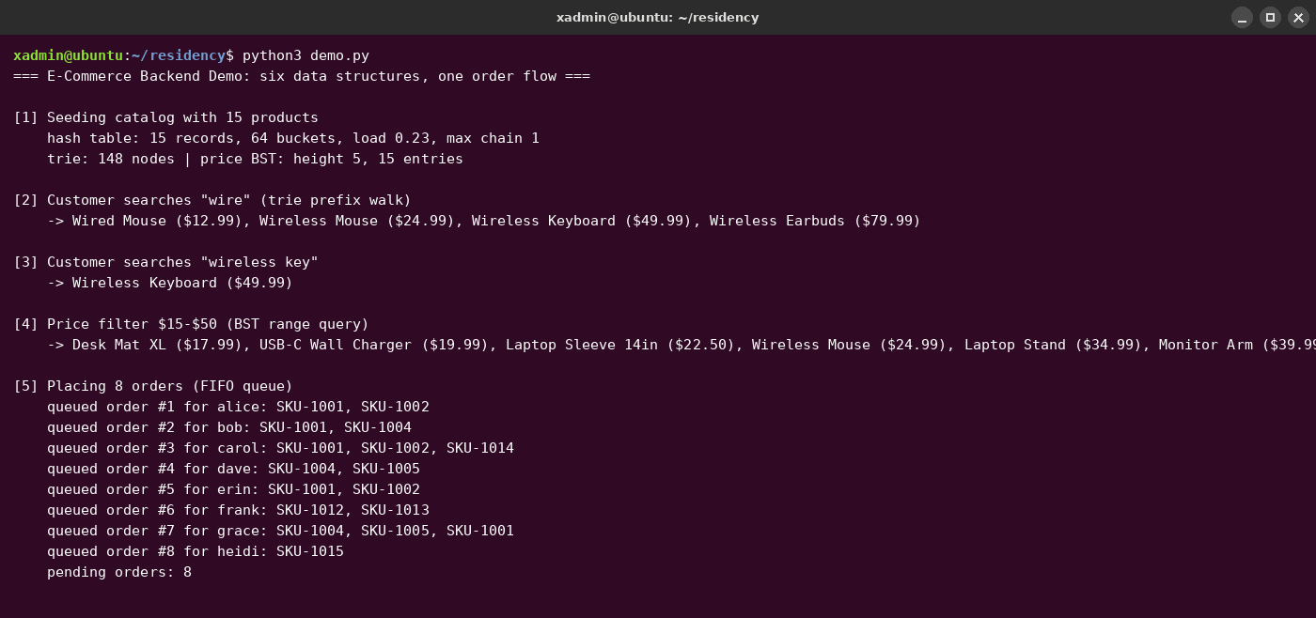
Figure 1. End-to-end demonstration, part 1: seeding, trie searches, price filter, order placement.
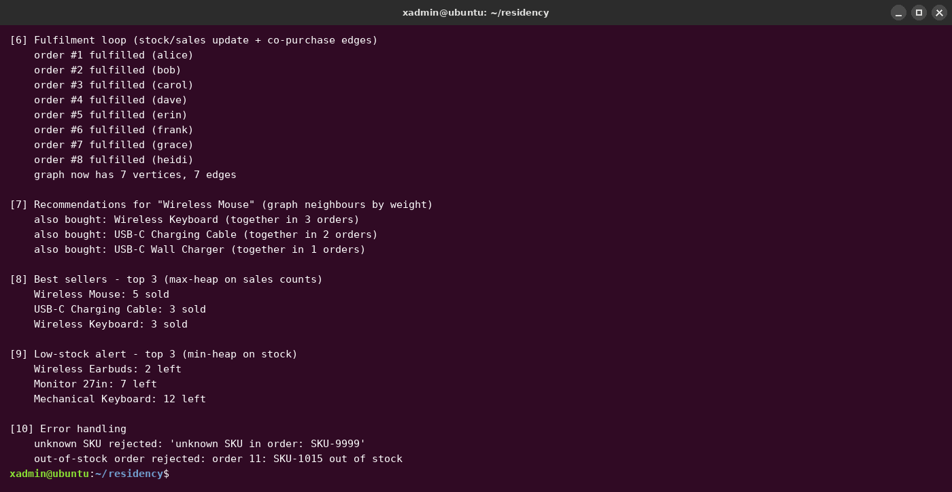
Figure 2. Demonstration, part 2: fulfilment feeding the graph, dashboards, error handling.
The demonstration also runs interactively. A browser portal (portal.py, built on the standard library's http.server so the project remains dependency-free) serves a single-page storefront in which every panel is answered by exactly one structure and is color-coded to it: live trie autocomplete, tree-served price bands, the hash-table catalog with per-product return buttons, graph-served co-purchase panels, a queue-backed cart and fulfilment flow, and three heap dashboards, with a metrics strip reporting each structure's live diagnostics (Figure 3). The portal also completes the merchandising loop with a returns workflow: an accepted return restocks through the catalog, cumulative returns are capped at units actually sold, and a most-returned dashboard ranks the returns counters with the same heap as the best sellers — keeping demand and dissatisfaction as separate, simultaneously visible signals.
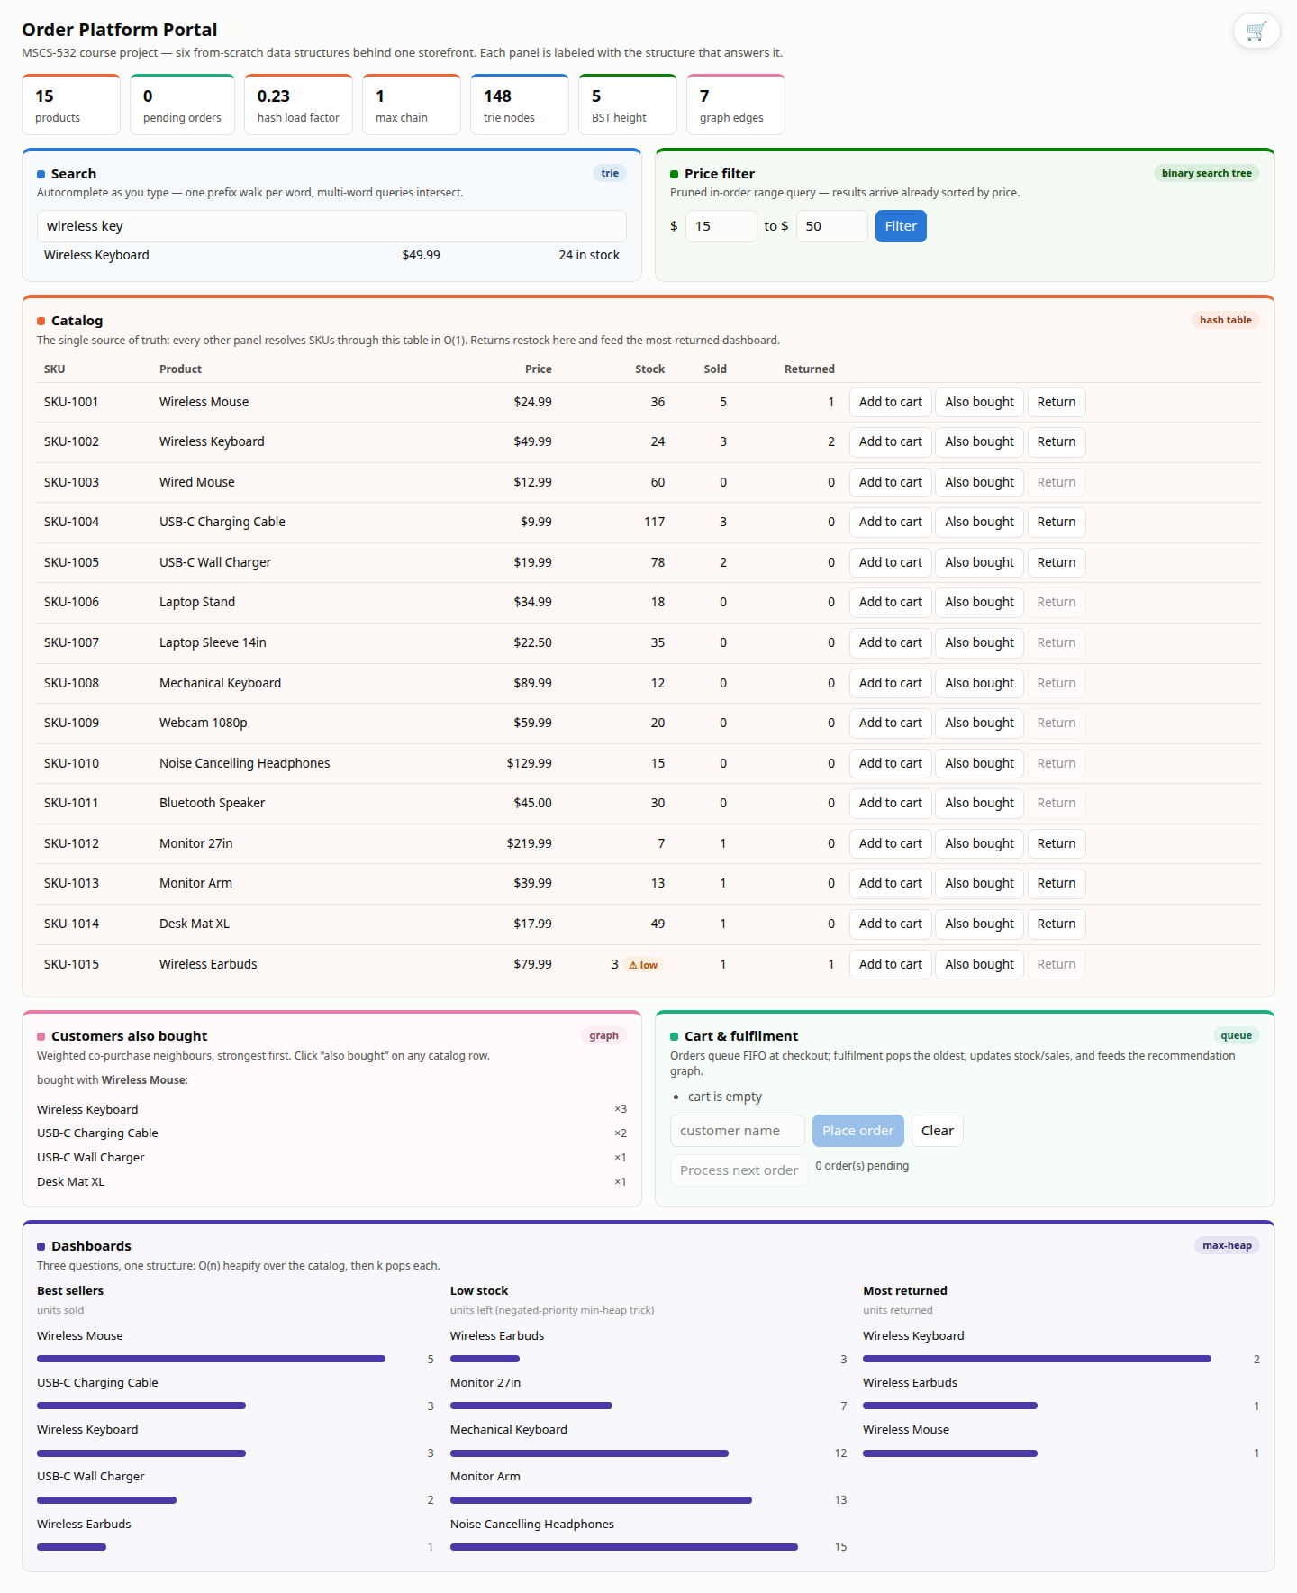
Figure 3. The browser portal: a live multi-word trie search, graph recommendations, and the three heap dashboards, each panel color-coded to its structure.
Testing and Validation
Correctness rests on forty-two unit tests organized by structure (Figure 4). Beyond happy paths, the tests target each design's specific failure modes: the hash table is filled through multiple resizes and every record re-verified, and its no-resize configuration is asserted to develop long chains; the queue is grown from a two-slot buffer and drained across the wraparound boundary; the price tree's range query is cross-checked against a brute-force scan over one thousand random prices; the heap's top-25 is compared with a full sort on two thousand random entries; and the facade's integration tests verify that removing a product cleans every index, that a failed order commits nothing, and that returns restock the catalog while cumulative caps reject returning more units than were ever sold. Two system-level stress tests complete the validation. Loading the price tree with four thousand strictly increasing prices produces the predicted degenerate height of 4,000 versus 25 for random order (Figure 8). Replaying twenty thousand orders against a deliberately undersized one-thousand-product catalog exhausts supply and forces 9,413 atomic rejections — the platform's behavior under a flash-sale load — while the same stream against the full catalog rejects only 234.
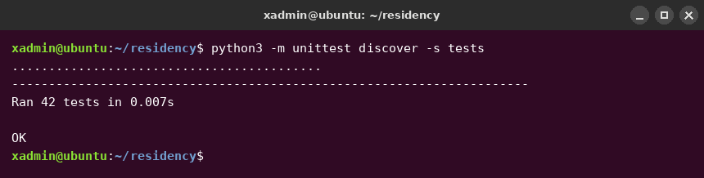
Figure 4. The unit-test suite: 42 tests passing.
Performance Evaluation and Optimization
The benchmark suite scales catalogs from one thousand to one hundred thousand products, generated with an adjective-noun-variant vocabulary so the trie faces realistic shared prefixes, and an order stream with quadratic popularity skew so hub products emerge as they do in real stores. Timings are best-of-five with time.perf_counter; memory is peak tracemalloc. Each structure is measured against the naive baseline a simpler implementation would have used.
The catalog experiment isolates the value of dynamic resizing. With resizing, lookups are flat at about 2.2 µs across two orders of magnitude of catalog size; frozen at 1,024 buckets, the same table degrades linearly to 10.1 µs with maximum chains 111 entries long (Figure 5) — the O(n/m) arithmetic of chained hashing made visible. Search shows the largest payoff: the linear scan reaches 82 ms per query at full scale while the trie answers in 1.83 ms, a 45-fold advantage that widens with size (Figure 6, log scale). The pruned tree serves a $100–$125 band returning 5,040 products in 1.2 ms against 6.9 ms for scan-and-sort (Figure 7), a 5.7-fold gain that grows with the fraction of catalog outside the band.
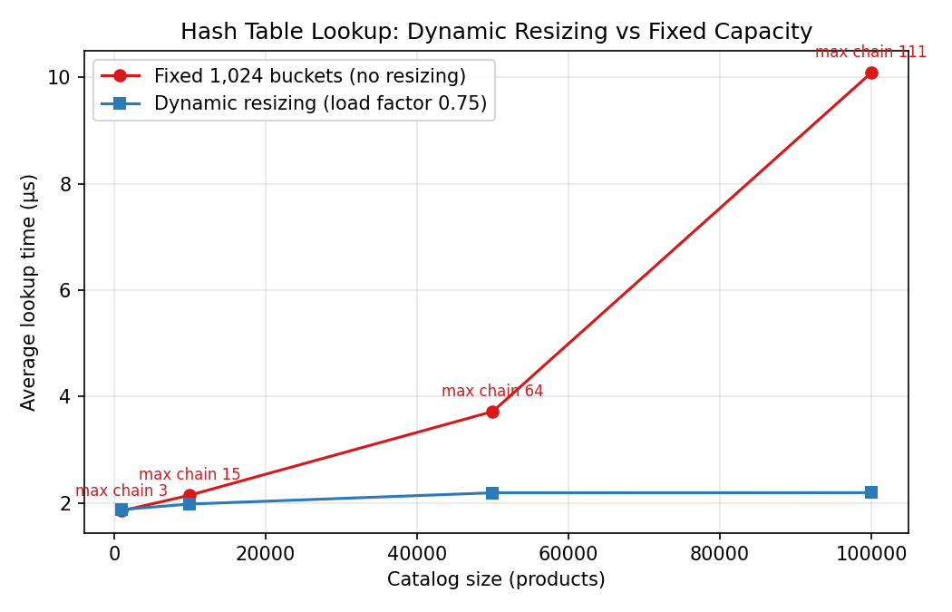
Figure 5. Hash-table lookups: resizing vs fixed capacity.
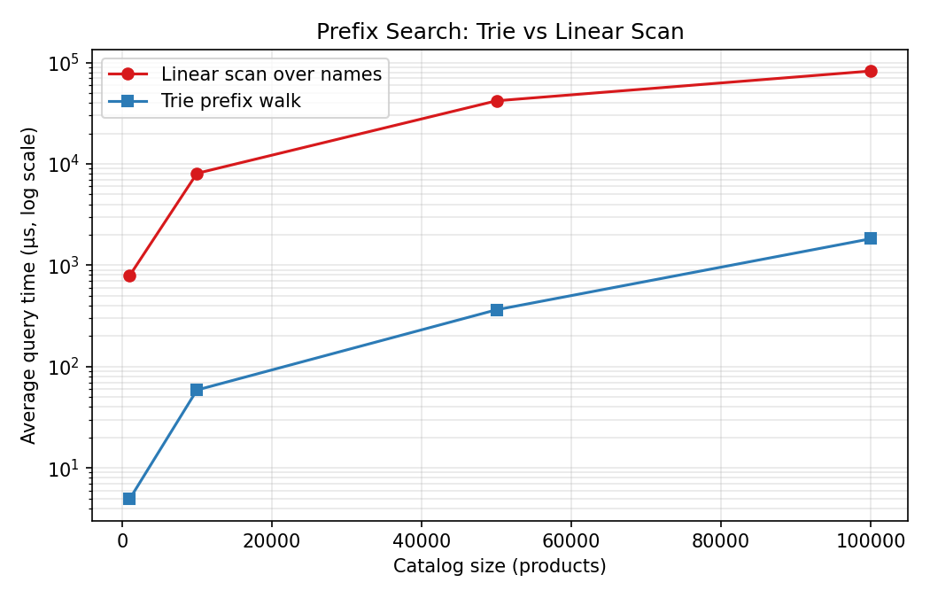
Figure 6. Prefix search, log scale: trie vs linear scan.
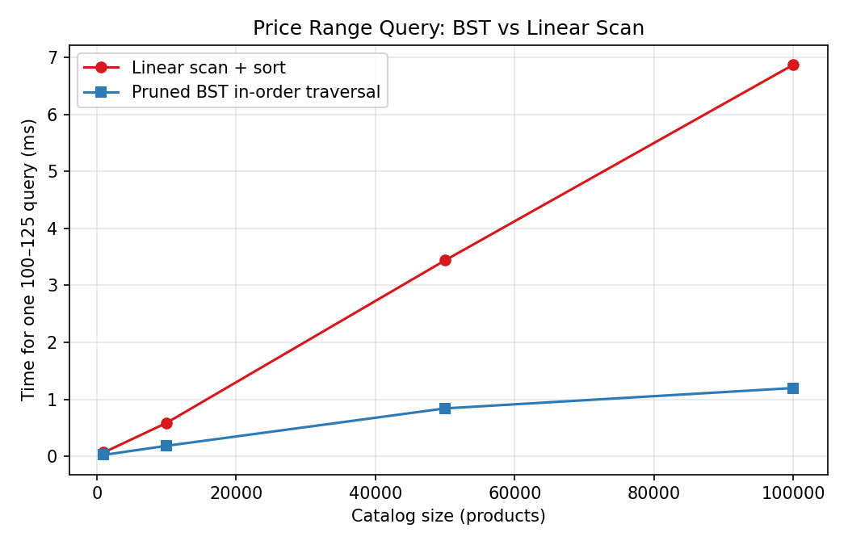
Figure 7. Price-band query: pruned BST vs linear scan.
One result cuts the other way, and reporting it honestly is part of the evaluation. The heap's O(n + k log n) top-k is asymptotically superior to a full O(n log n) sort (Knuth, 1998), yet the pure-Python heap (76 ms at n = 100,000) only ties Python's built-in sort (74 ms), because Timsort runs in C while every sift-down comparison runs in the interpreter (Figure 9). Constant factors set by the execution environment consumed the asymptotic advantage at every scale measured. The heap stays in the design for what the cold benchmark does not measure: it supports incremental updates without re-sorting the world. End to end, the integrated pipeline fulfils about 44,422 orders per second against the full catalog, declining only modestly with catalog size since per-order work is O(1); the populated system peaks at 65 MB (Figure 10), with the trie the dominant consumer as its per-character nodes carry Python object overhead.
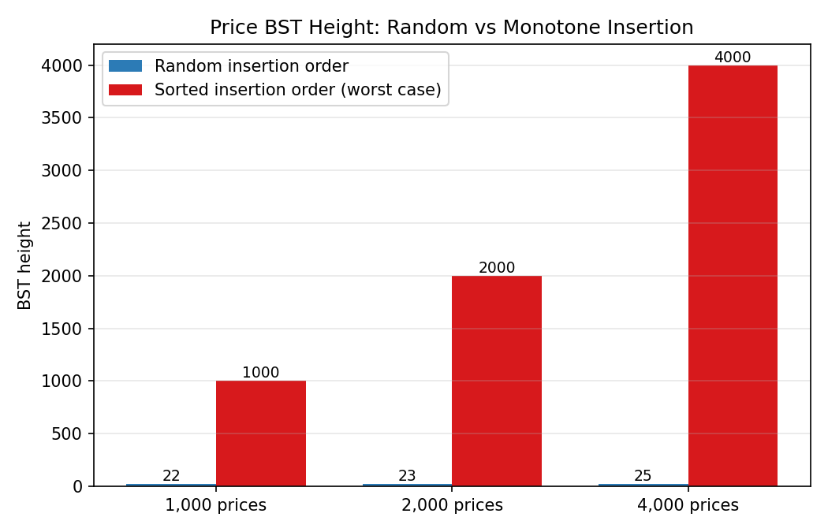
Figure 8. BST height under random vs monotone insertion.
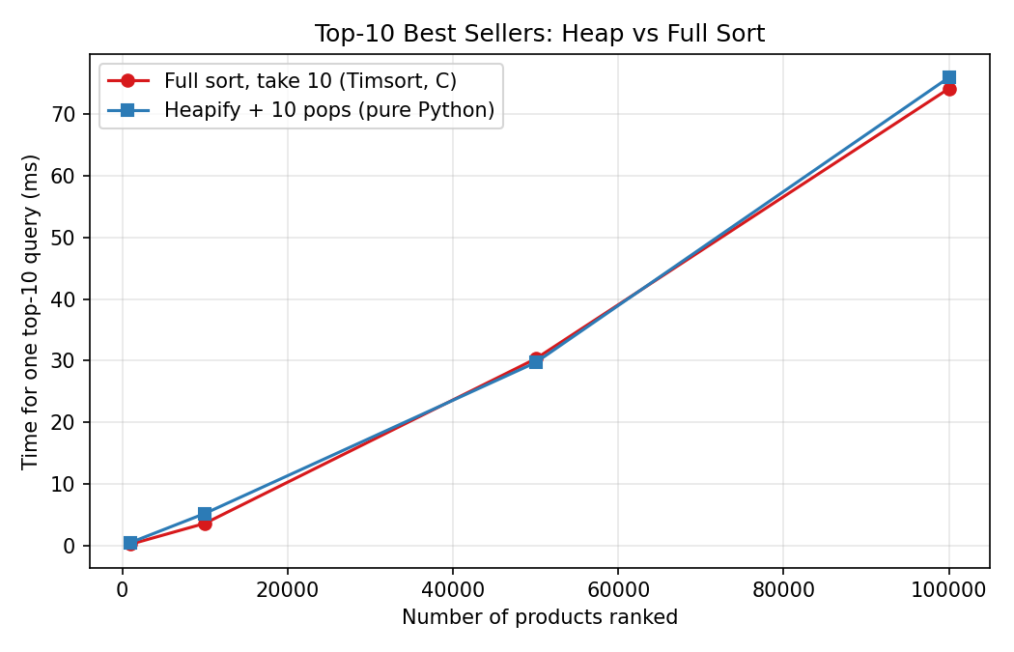
Figure 9. Top-10 ranking: pure-Python heap ties the C-implemented sort.
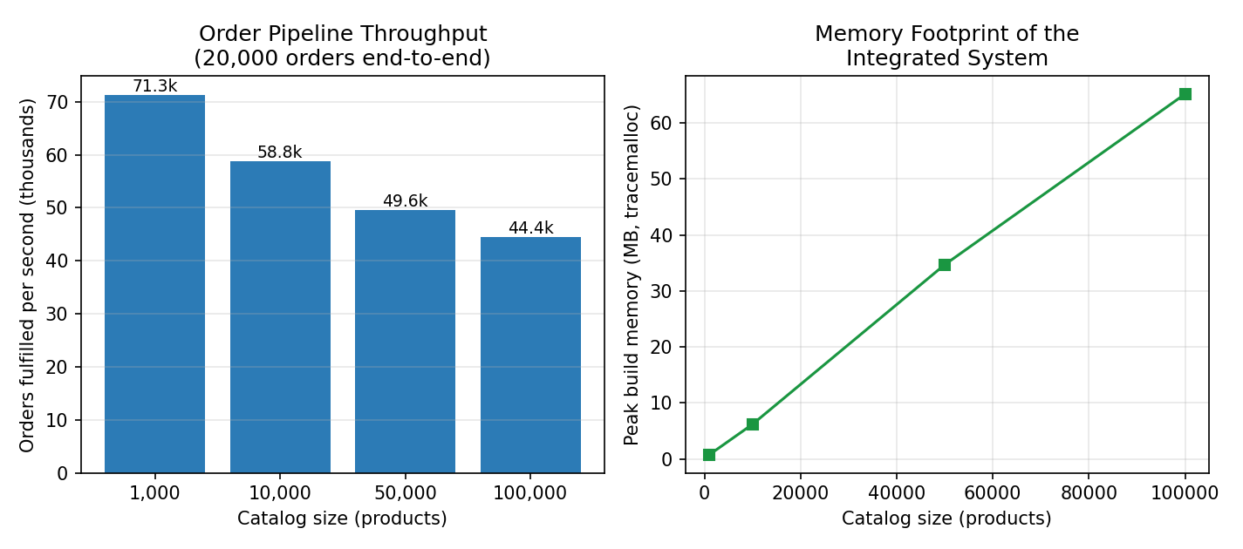
Figure 10. Throughput and memory of the integrated system.
Operation (n = 100,000) | Naive baseline | Optimized structure | Gain
Catalog lookup | 10.1 µs (fixed buckets) | 2.2 µs (resizing) | 4.6×
Prefix search | 82.4 ms (linear scan) | 1.83 ms (trie) | 45×
Price-band query | 6.9 ms (scan + sort) | 1.2 ms (pruned BST) | 5.7×
Top-10 ranking | 74 ms (full sort) | 76 ms (heap) | ≈1× (tie)
Order fulfilment | — | 44,422 orders/s end to end | —
Discussion: Impact and Practical Implications
Three transferable conclusions emerge. First, composition beats generality: the platform's speed comes not from any single clever structure but from routing each workload to the structure whose asymptotics fit it, glued by a constant-time source of truth — the same architecture, at teaching scale, that production retailers run (Linden et al., 2003). Second, optimizations must be measured in their execution environment: the resize policy repaid itself five-fold, while the heap's textbook advantage evaporated against a C-implemented sort, and only measurement distinguishes the two cases. Third, worst cases documented at design time convert into cheap tests later: the monotone-insertion collapse and the flash-sale exhaustion were both predicted in Phase 1, and both surfaced in Phase 3 exactly as predicted, validating the discipline of writing risks down before writing code.
Limitations and Future Directions
The measured limitations chart the future work. The price tree needs self-balancing — AVL or red-black rotations, or a B-tree variant in the Bayer and McCreight (1972) tradition — before it can accept sorted bulk loads such as a supplier price file. The co-purchase graph grows monotonically; a long-lived deployment would add edge-weight decay or pruning so stale pairings age out. The trie's memory could be reduced by radix compression of single-child chains. Beyond structural work, the natural evolution of the recommendation subsystem is toward learned models (Zhang et al., 2019), for which the co-purchase graph built here supplies both the baseline and the training signal. Finally, a production system would shard these structures across processes to escape the interpreter constants the heap experiment exposed; the facade boundary makes that refactoring localized.
Use of AI Assistance
The group used Claude (Anthropic, 2026) as a development assistant for parts of this project, most heavily in producing the final presentation, and reports that use here in the interest of academic transparency. The division of labor was deliberate: the group supplied the design decisions, the measured data, and the review; the assistant accelerated the mechanical work of turning them into polished artifacts. For the presentation specifically, the assistant converted the project's panel-by-panel portal guide into slides, cropped the portal screenshots into slide-ready panels, applied a consistent visual theme derived from the portal's own color coding, embedded the spoken script into each slide's presenter notes, and divided the eighteen slides into five near-equal presenter blocks whose order was drawn at random. A representative prompt from that work was: "Work on the presentation and put screenshots from the web portal into it, with the explanation on each slide; divide the slides evenly among the five of us, choose the order randomly, and start Xhon as the main presenter."
What the assistant did well was consistency at scale: every number on a slide or in a caption is read from the same benchmark JSON the charts are drawn from, so text and figures cannot drift apart; figure renumbering across a sixty-page report happened without a dangling reference; and each generated slide was rendered and visually inspected rather than assumed correct. What it did wrong is equally instructive, and each fault was caught by group review rather than by the tool itself. Its first implementation of the returns feature capped only the quantity of a single return against units sold, not the running total — the same unit could be returned repeatedly — and the flaw surfaced only when a group member questioned why certain Return buttons were disabled, which prompted a re-examination, a cumulative cap, and two new unit tests. It also left a stale figure caption claiming forty passing tests after the suite had grown to forty-two, and its first portal slide used a portrait screenshot that could not fit a sixteen-by-nine slide legibly, requiring a purpose-built landscape composite. The group's conclusion mirrors the report's own thesis: AI assistance, like an asymptotic advantage, is a claim that must be verified by measurement — every generated artifact was run, tested, or rendered and reviewed before it was accepted.
Conclusion
The project set out to translate data-structure theory into a working, measured system and closes with that translation complete: six structures implemented from scratch, proven correct by forty-two tests, integrated into one platform that fulfils tens of thousands of orders per second, and evaluated honestly against baselines — including the one experiment where theory's promise was consumed by constant factors. The exercise demonstrated in miniature the daily engineering reality of the e-commerce domain: asymptotics choose the candidates, but measurement chooses the winners.

References
Anthropic. (2026). Claude [Large language model]. https://claude.ai
Bayer, R., & McCreight, E. (1972). Organization and maintenance of large ordered indexes. Acta Informatica, 1(3), 173–189. https://doi.org/10.1007/BF00288683
Cormen, T. H., Leiserson, C. E., Rivest, R. L., & Stein, C. (2022). Introduction to algorithms (4th ed.). MIT Press.
Fredkin, E. (1960). Trie memory. Communications of the ACM, 3(9), 490–499. https://doi.org/10.1145/367390.367400
Knuth, D. E. (1998). The art of computer programming: Vol. 3. Sorting and searching (2nd ed.). Addison-Wesley.
Linden, G., Smith, B., & York, J. (2003). Amazon.com recommendations: Item-to-item collaborative filtering. IEEE Internet Computing, 7(1), 76–80. https://doi.org/10.1109/MIC.2003.1167344
Pagh, R., & Rodler, F. F. (2004). Cuckoo hashing. Journal of Algorithms, 51(2), 122–144. https://doi.org/10.1016/j.jalgor.2003.12.002
Sarwar, B., Karypis, G., Konstan, J., & Riedl, J. (2001). Item-based collaborative filtering recommendation algorithms. Proceedings of the 10th International Conference on World Wide Web, 285–295. https://doi.org/10.1145/371920.372071
Zhang, S., Yao, L., Sun, A., & Tay, Y. (2019). Deep learning based recommender system: A survey and new perspectives. ACM Computing Surveys, 52(1), Article 5. https://doi.org/10.1145/3285029

